CHANGE REQUEST steps for Devops - Production release.
Steps Before Release
Update Change request with Azure Work item details.
Change requests (CR’s) are created automatically using GLAPI Process. Requests does not provide details on azure stories that are associated to the CR.
- DevOps to update CR notes with Azure story details as below.
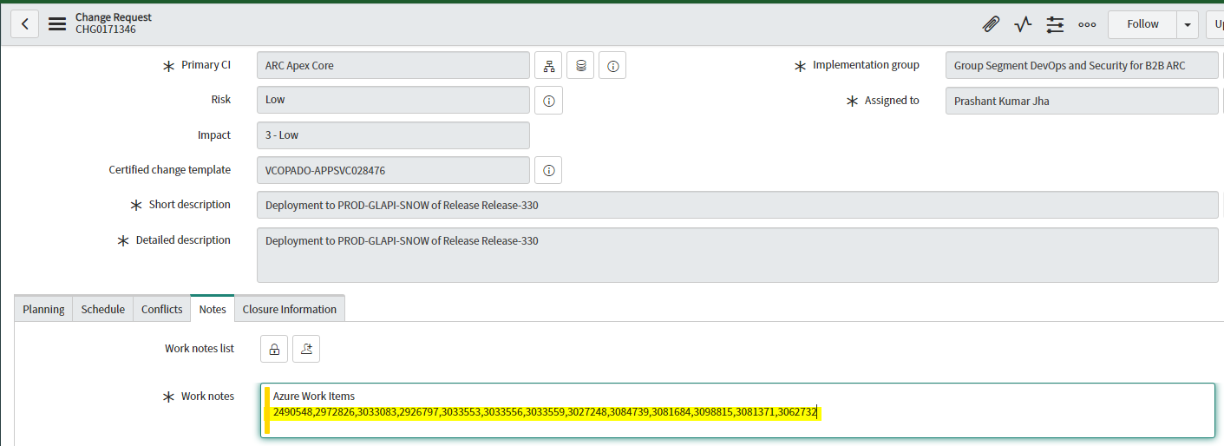
Steps After Release

Step 1: CR will be in Implement state
  - Add all the details marked with asterisk first along with work note comment.
  - Then click on REVIEW button.
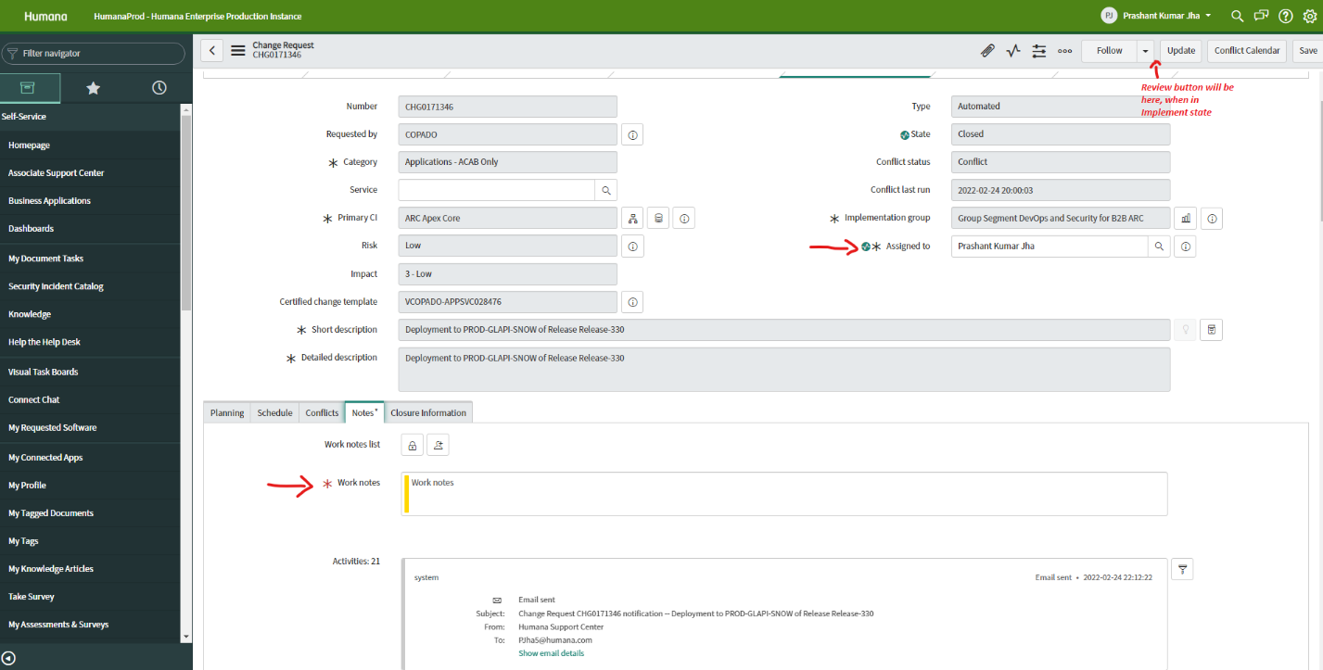

Step 2: CR will be in REVIEW state
  - Add all the details marked with asterisk first along with work note comment.
  - Then click on SAVE button
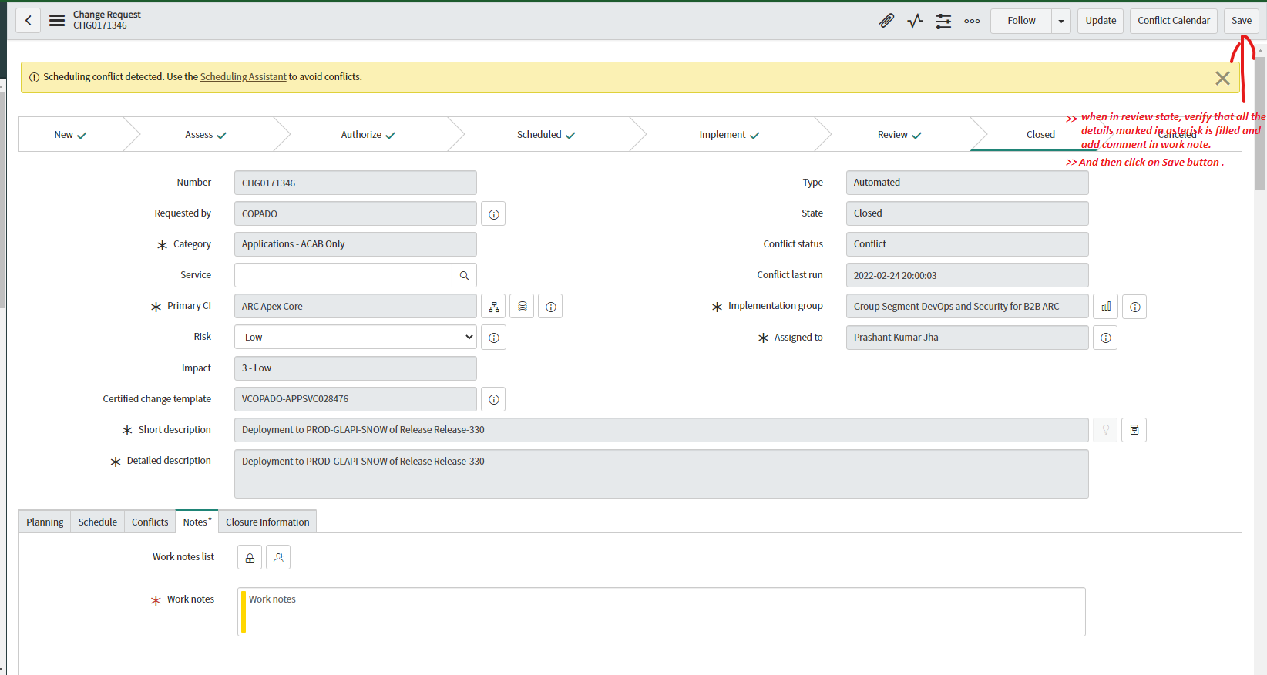

Step 3: CR will be in CLOSED state
  - Add all the details marked with asterisk first along with work note comment.
  - Go to closure information section, select Successful from the drop down and add relevant comment.
  - Then click on SAVE button.
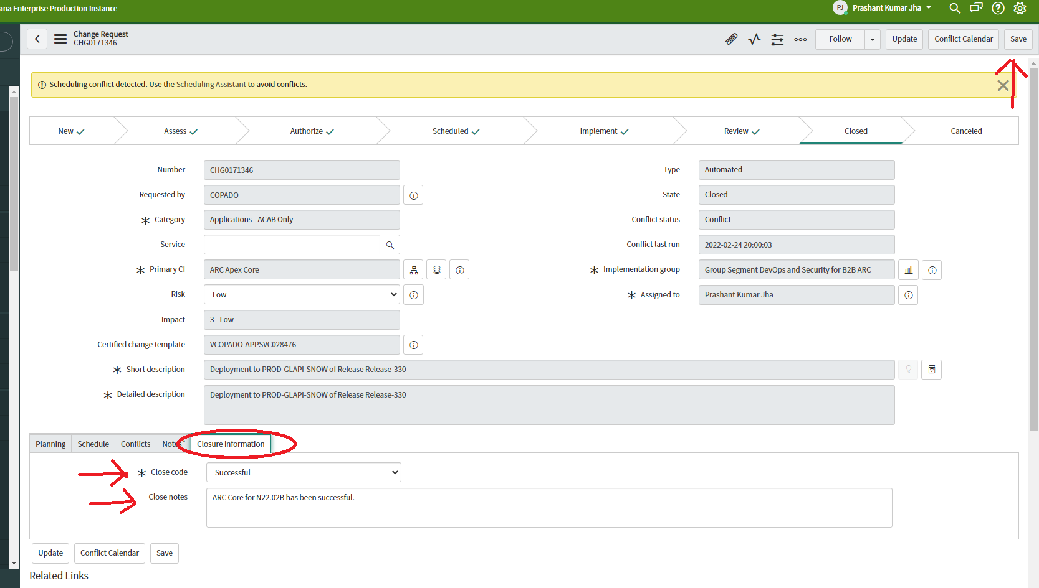

Step 4: Repeat all 3 steps for both Group CRM and DP 360 CR.

